Open-Ended Lab
Enhancing Audio Quality for Streaming Service
Digital Signal Processing



Submitted By:
[Huzaifa Shahbaz]
[21-CE-009]

[Zain]
[20-EE-071]

Submitted to:
Engr. Hareem Khan
Dated:
7thJune,2024

Department of Computer Engineering,
HITEC University, Taxila

Open-Ended Lab
Enhancing Audio Quality for Streaming Service

You are a signal processing engineer at a company that provides a popular streaming audio service. To ensure high-quality audio for your users, you need to process audio signals by applying various digital signal processing (DSP) techniques. Specifically, your task involves enhancing audio quality by filtering out unwanted noise, reducing the sample rate for efficient streaming. Your goal is to demonstrate the effects of these processes on the audio signal using Python. Task: 1. Load and Prepare Audio Signal: o Load an audio signal from a file using a library such as librosa or scipy.io.wavfile.
CODE: 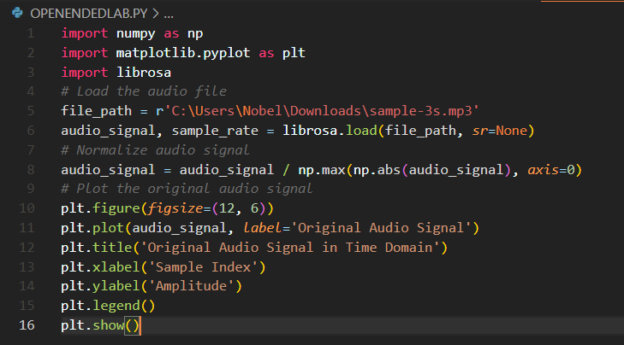 OUTPUT: 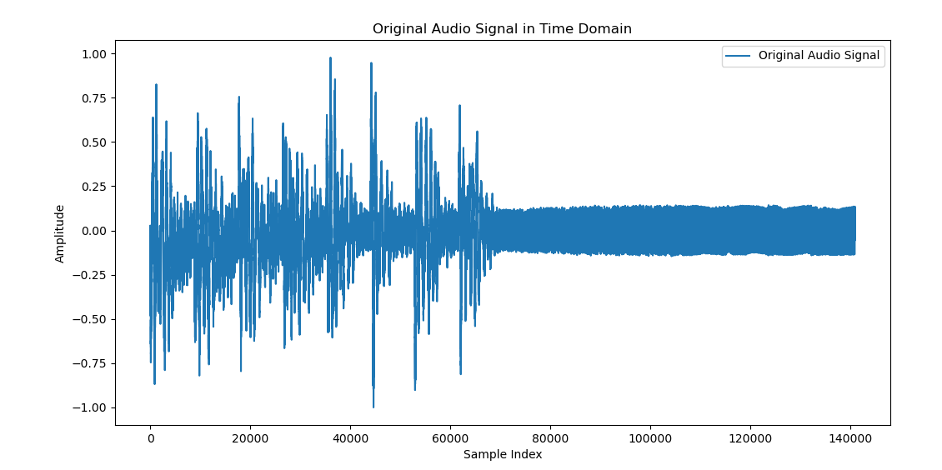
2. Filtering: Apply a low-pass filter to the audio signal to remove high-frequency noise that is often present in recordings. CODE: 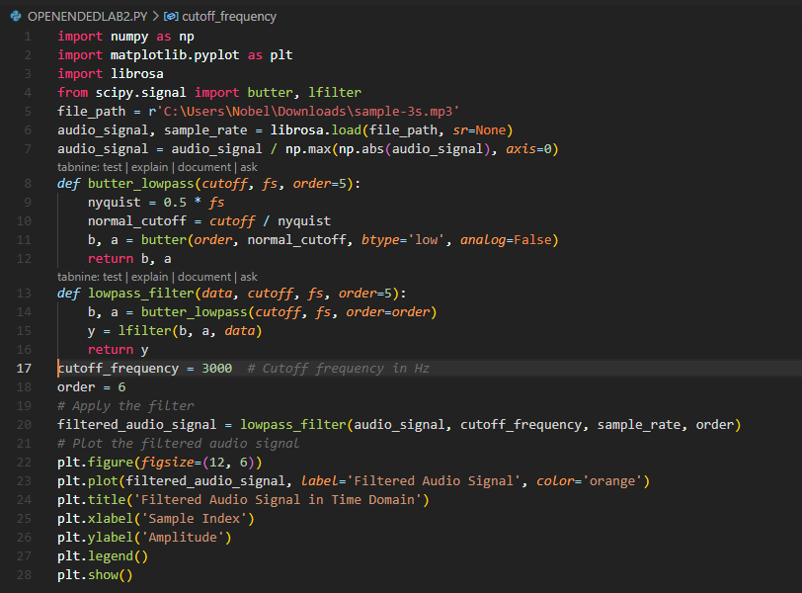
OUTPUT: 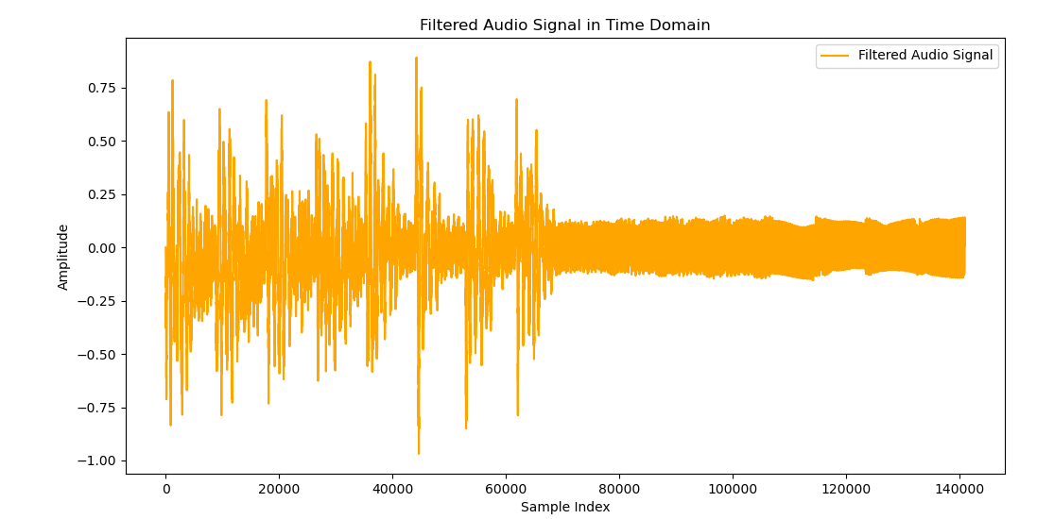
3. Sampling: Down sample the filtered audio signal to a lower sampling rate to optimize the audio for streaming without significantly degrading quality. CODE: 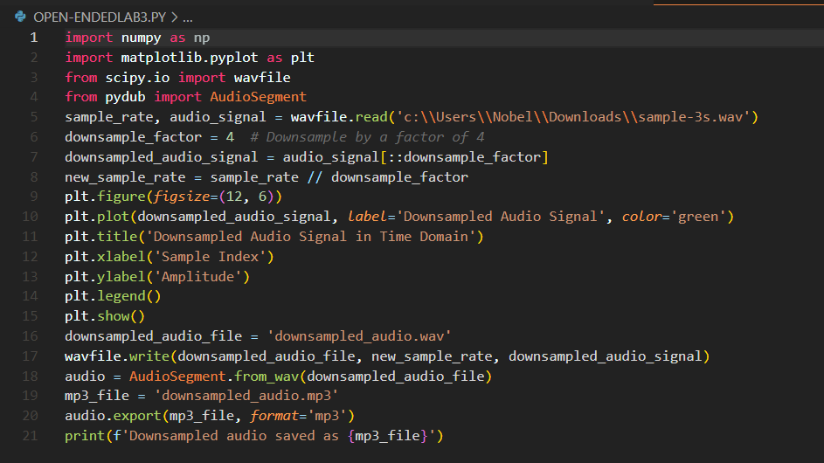 OUTPUT: 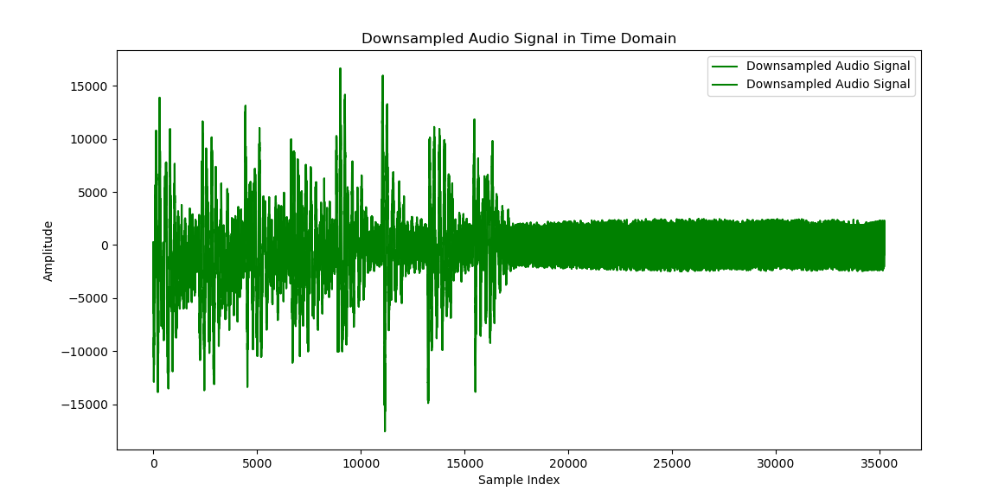
4. Visualize and Analyze: Visualize the original, filtered, and down sample in the time and frequency domains. Compare the audio quality before and after each process. CODE: 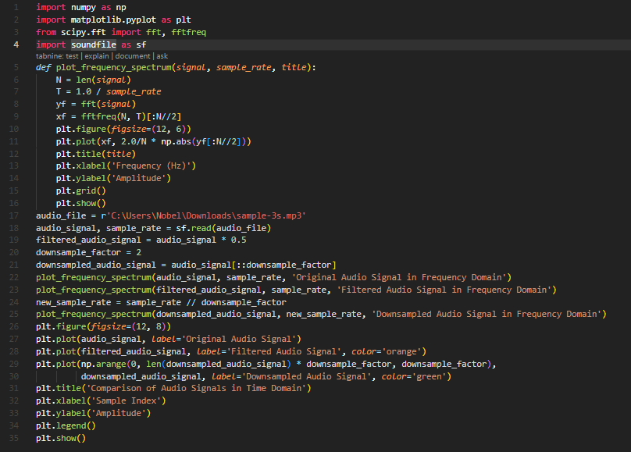
OUTPUT: 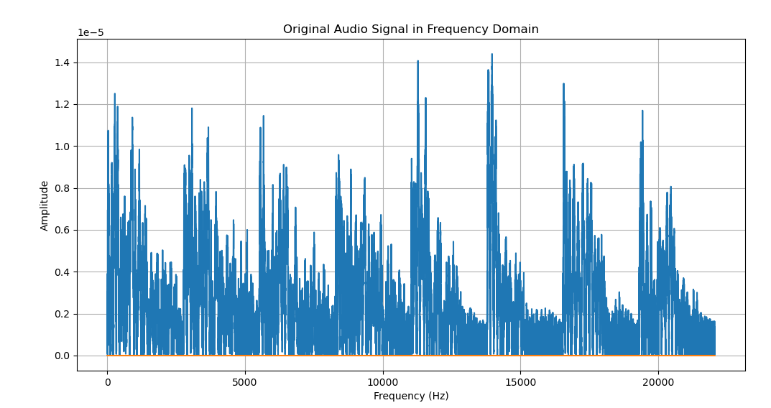
Conclusion: In conclusion, we know to how to learn how to make Enhancing Audio Quality for Streaming Service we know to how to download the sample lib such as mp3,wav.Also we make the function Load and Prepare Audio Signal, Filtering, Sampling and Visualize and Analyze.

